Embedded Linux Boot Process Course

Table of Contents
Linux Booting Process 3
RBL (ROM Bootloader) 3
SPL or MLO (Secondary Program loader / Memory Loader) 3
U-boot 3
RBL (ROM Bootloader) 3
Summary 5
MLO/ SPL 6
Why can’t RBL directly loads U-boot? 6
Booting RBL and MlO on BBB 6
SD card settings 6
Booting of MLO 8
Testing U-boot image on BBB 9
U-boot additional things to know 10
Job 10
uEnv.txt 10
uEnv.txt file contents 11
Decoding the U-boot Header of UImage Manually using U-boot commands 12
Reading U-boot header information of the UImage Manually 12
U-Boot to Linux boot flow 14
Kernel Entry U-boot 14
Head.s 14
Head-common.c 15
Main.c 15
UEnv.txt and Initramfs 16
Creating uEnv.txt 16
Creating uEnv.txt file 18
Initramfs 19
Is initramfs compulsory? 19
Why initramfs is used? 19
What does initramfs contain? 19
How initramfs is loaded? 20
Steps to generate initramfs 20
Booting BBB over Serial Port 21
TFTP booting protocol 23
Prerequisites 23
U-Boot 26
Compiling U-boot and MLO 26
Cross tool Chain Installation 26
Linux kernel Image build 27
BusyBox 29
Advantages of BusyBox 29
Busybox compilation 30
Testing Boot image and busybox on BBB 31
Build root 43
Configuring and building buildroot 43
Build root and U-boot configuration 45

Linux Booting Process
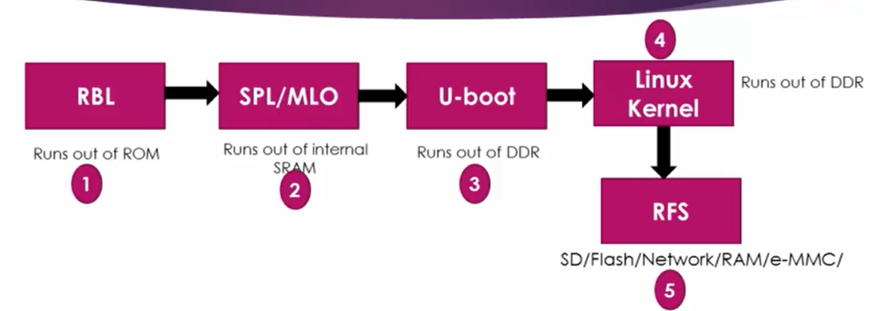

RBL (ROM Bootloader)
- Very first piece of code to run the Soc when power supply provided to board
- Developed by SoC vendor and burned to ROM memory
- We don’t have access to rewrite or modify the bootloader code
- The key role or job of RBL is to load the secondary bootloader that is SPL (Secondary Program loader or MLO (Memory Loader) from internal memory of the SoC

SPL or MLO (Secondary Program loader / Memory Loader)
- It is to load and execute third stage bootloader that is U-boot from the DDR memory on the board

U-boot
- It is the third stage bootloader responsible for loading and executing the Linux kernel image from the DDR memory
=========================================================================

RBL (ROM Bootloader)

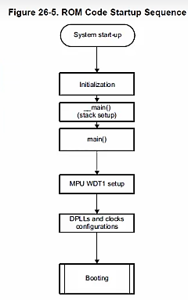

- On Power it initializes the stack setup, then calls bootloader main ()
- Main () will initialize and stars the watch dog timer for 3 mins
- If within 3 mins RBL cannot load the second stage bootloader then it will reset the system again
- After watching dog, it will set up the system clock using PLL block

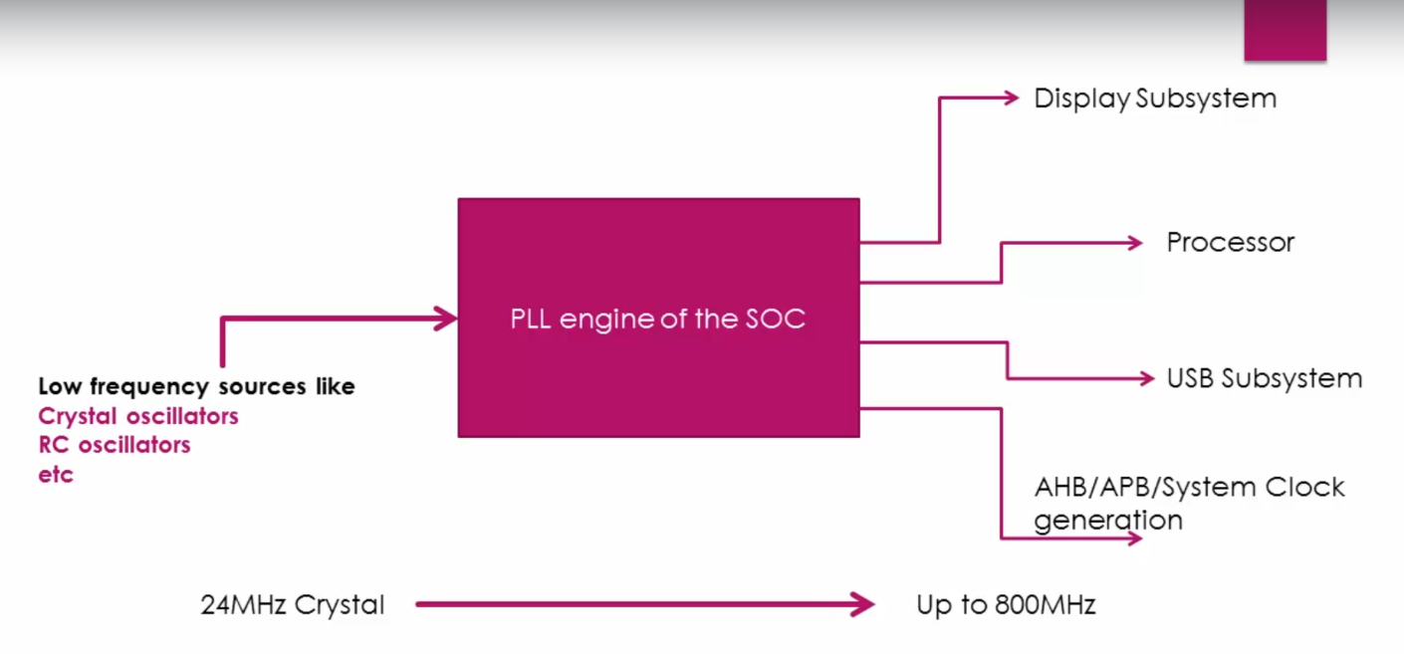

- PLL engine is a frequency generator which takes low frequency as input via crystall oscillators and generates very high frequency that can be used for processors, and peripherals
- During clock initialization it checks sysboot[14:15](pins)
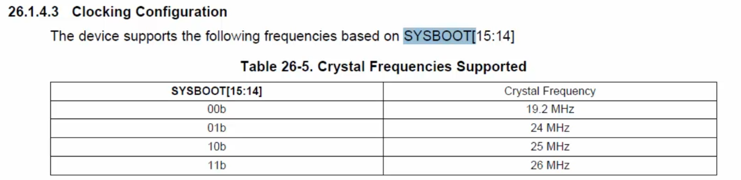

- By default, for beaglebone black is configured for 24Mhz meaning pin 14 is tied with VCC and pin 15 tied with GND
- For this configuration PLL provide 500Mhz from 24Mhz
- We can’t change the clock frequency in RBL stage it is only possible during MLO
- Next is a boot() which will find the MLO and copy the MLO contents to internal RAM of SoC
- MLO Structure looks like below
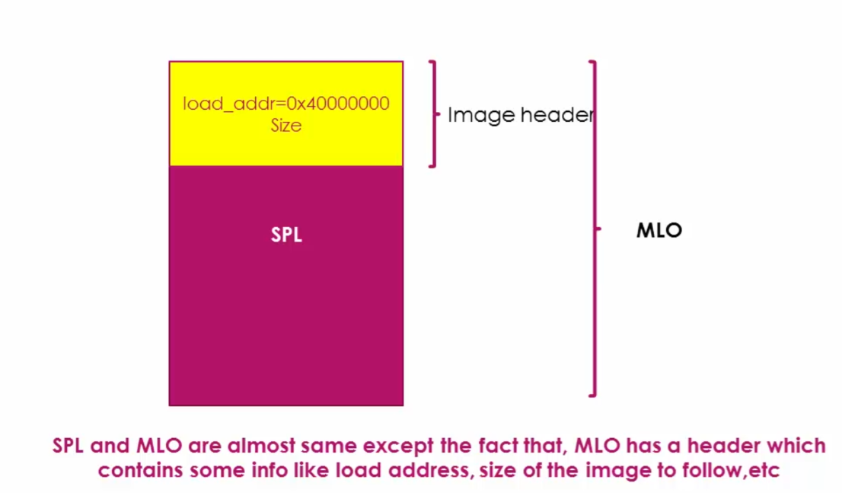

Summary
- Stack Setup
- Watch dog timer 1 configuration (set to 3 minutes timeout)
- System clock configuration using PLL
- Search Memory devices or other bootable interfaces for MLO or SPL
- Copy MLO or SPL into internal SRAM of the chip
- Execute MLO or SPL

MLO/ SPL
- It initializes the UART console prints for debug messages
- It reconfigures PLL if required
- Initialize the DDR memory to use it further
- It will do Mux configuration (Single pin used for multipurpose like SPI/CANLI2C/)
- Let say the MLO is going to get the U-boot which found on MMC0/ MMC1 (Multimedia Card like Memory card) then it will do mux configuration to bring out the MMC0 or MMC or eMMC (Soldered to board non removable storage)
- After hardware initialization it loads / copy U-boot image to DDR RAM
- The U-Boot also has own header which describes the start address (load address)
- Note U-boot size is bigger compared to MLO so it is not possible to load it on internal SRAM, U-boot will always load to DDR RAM (external / extra RAM out of SoC)

Why can’t RBL directly loads U-boot?
- Size of SRAM is limited (128kb) Even in the 128kb, some space is reserved for stack, and some memory regions are already secured, so less than 128kb is available so U-boot will not fit, it is usually in the size of 500kb to 1.5Mb or more

Booting RBL and MlO on BBB
- Pre-built binaries used can be found on this link: https://github.com/niekiran/EmbeddedLinuxBBB/tree/master/pre-built-images/Angstrom_Demo

SD card settings
- Two Partition need to do with SD card to hold the files
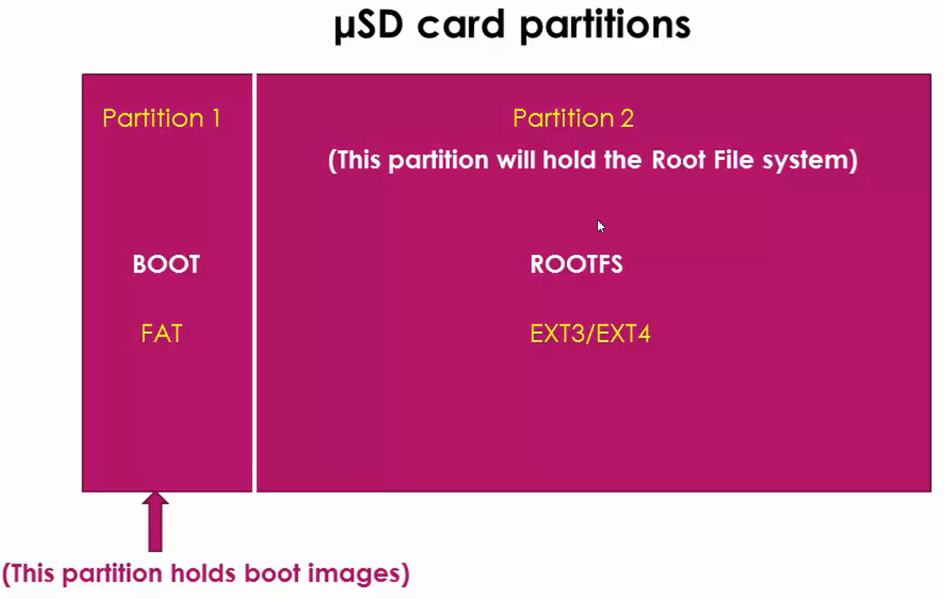

- Connect SD card read to PC
- Execute dmesg to check the sd card name
- Install GParted tool
- Open the software
- Select sd card device /dev/sdb(7.28 Gib)
- Select sd card right click unmount
- Select sd card right click delete
- Select sd card right click New File system as fat16 Label as BOOT New size as 1024Mb(1gb) Add now we could see New Partiton created also remaining storage shows as unallocated
- Select unmounted right click New File system as ext3 Label as ROOTFS New size as 6430Mb(~6gb) (Select all remaining memory don’t leave anything unallocated) Add
- Select BOOT partition click apply buttonapplyclose
- Right click BOOT partition Manage Flags tick boot Close
- Now we could see Sd card split into two partition named BOOT and ROOTFS
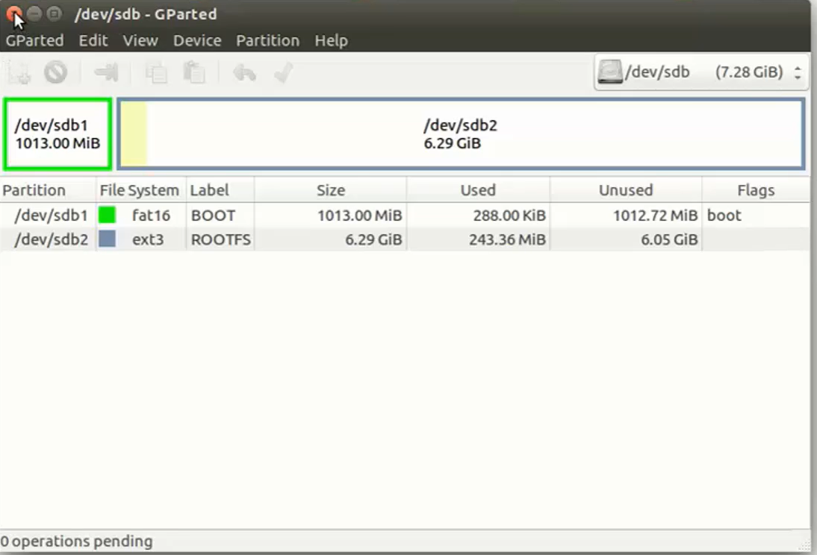

- Rename MLO-beaglebone-2013.04 file MLO and paste it to BOOT folder, use root access to copy otherwise it won’t copy

Booting of MLO
- Connect debugger UART pins with TTL to USB converted and connect TTL to PC
- Open minicom do minicom UART settings and open it
- Once powered by default BBB will boot from eMMc
- To boot from SD card, put BBB to power down mode by long pressing the power button until the power LED turns off
- Press and hold the S2 button then press the power button now it will boot from SD card
- We got the U-boot error below because we didn’t copied the U-boot

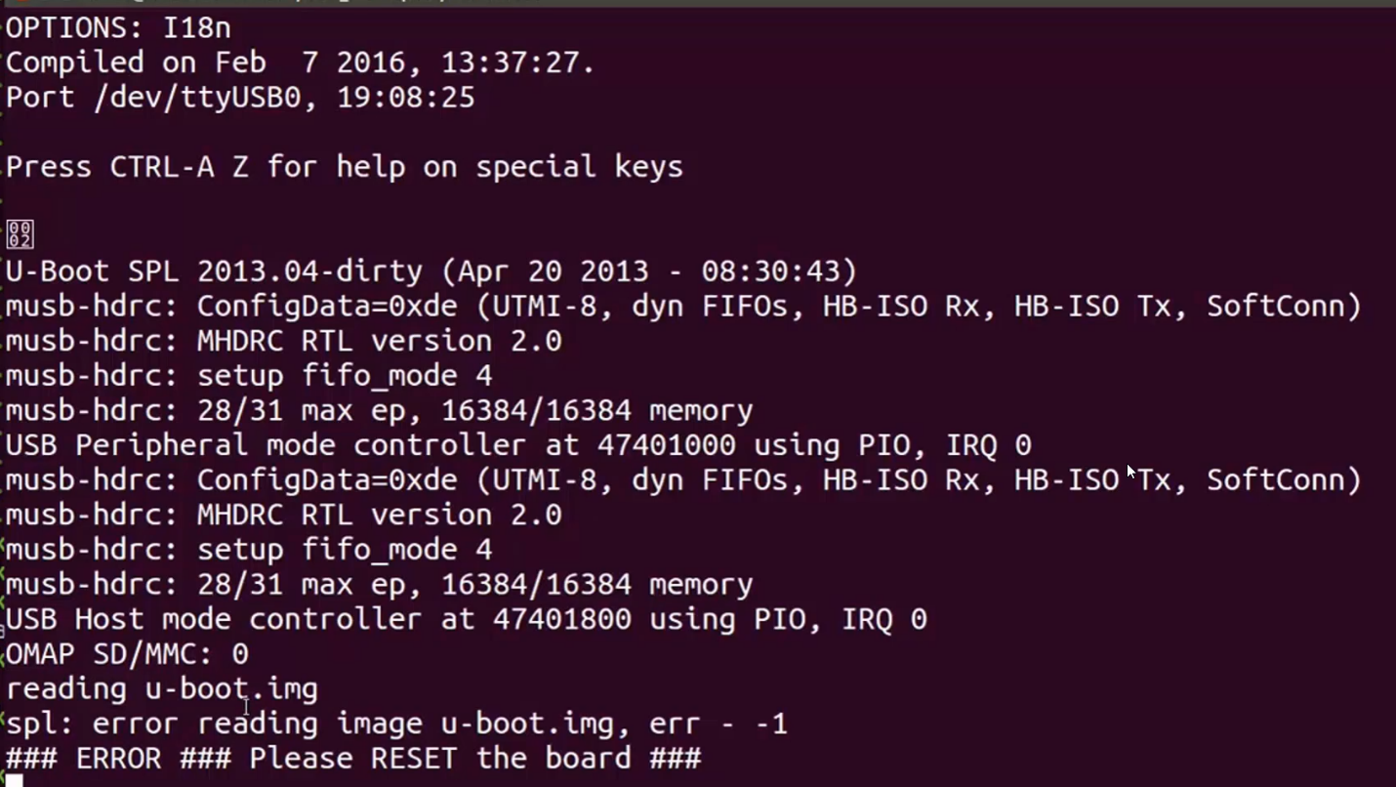

Testing U-boot image on BBB
- Rename u-boot-beaglebone-2013.04-r0.img to u-boot.img because the MLO always looks for that name see the above image
- Copy the renamed file to BOOT partition
- Unmount SD card and remount it
- Again Press and hold the S2 button to boot from SD card, then powerup the board
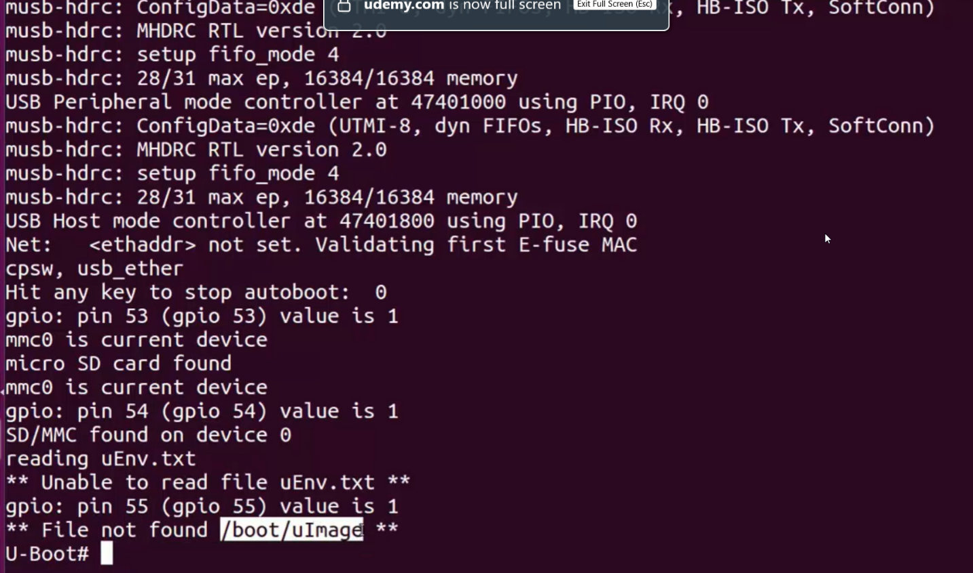

- Now we got the error message that is File not found /boot/uImage because we did’nt copied the file to rootfs

U-boot additional things to know

Job
- The Job of U-boot is to initialize the peripherals like I2C, NAND, FLASH, ETHERNET, USB, UART, MMC, etc.
- Loads the kernel Image from various sources to DDR memory of the board
- Boot Sources: USB, eMMC, SD card, Ethernet, serial port, NAND flash, etc.

uEnv.txt
- It consists of environmental variables of U-boot
- It directs U-boot to how to behave
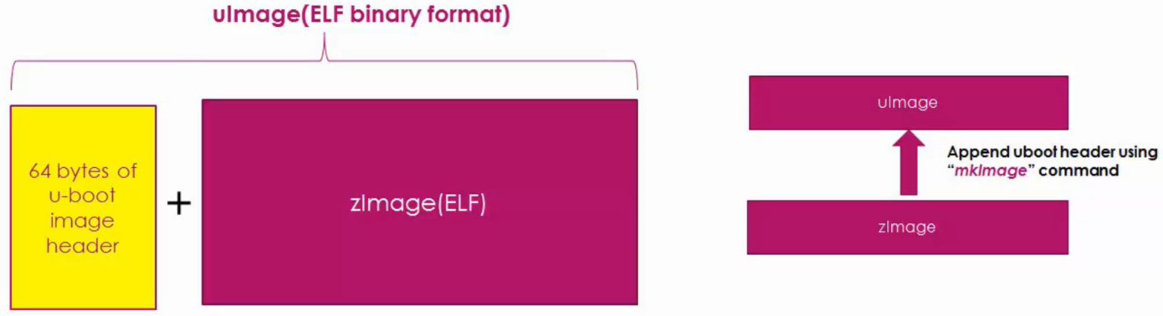

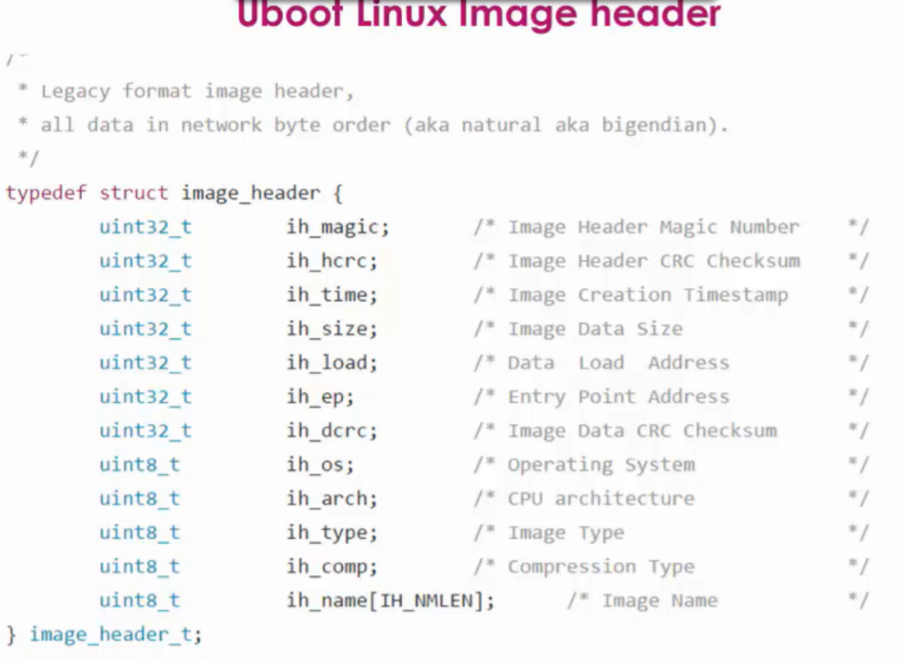
- U-image is the combination of u-boot header and zimage.elf

- Extract Angstrom-systemd-image-eglibc-ipk-v2012.12-beagleboard.rootfs.tar.xz file
- Copy all the contents(files and folders) to ROOTFS folder
- U-boot present inside BOOT partition but kernel Image that is ZImage present inside ROOTFS folder so U-boot don’t know where it is exactly we have to explicitly tell U-boot to find the Zimage for that we are using the uEnv.txt file
- Copy paste the uEnv.txt file to BOOT folder

uEnv.txt file contents
console=ttyO0,115200n8
ipaddr=192.168.7.2
serverip=192.168.7.1
loadaddr=0x82000000 DDR memory start address
fdtaddr=0x88000000 dtb file address
loadfromsd=load mmc 0:2 ${loadaddr} /boot/uImage;load mmc 0:2 ${fdtaddr} /boot/am335x-boneblack.dtb
linuxbootargs=setenv bootargs console=${console} root=/dev/mmcblk0p2 rw
uenvcmd=setenv autoload no; run loadfromsd; run linuxbootargs; bootm ${loadaddr} - ${fdtaddr}

- loadfromsd=load mmc 0:2 ${loadaddr} /boot/uImage;load final Uimage from this folder and past all the conetent (memory) to loadaddr that is DDR address (0x82000000)
- Similarly, for dtb load mmc 0:2 ${fdtaddr} /boot/am335x-boneblack.dtb
- root=/dev/mmcblk0p2 rw mount ROOTFS partition
- uenvcmd=setenv autoload no; run loadfromsd; run linuxbootargs; bootm ${loadaddr} - ${fdtaddr} these are u-boot commands

- Press and hold s2 button power up the board
- Now it will boot and loads the kernel image and dtb to DDR memory, and executes the kernel so now it will as for a login
- Beaglebone login:root

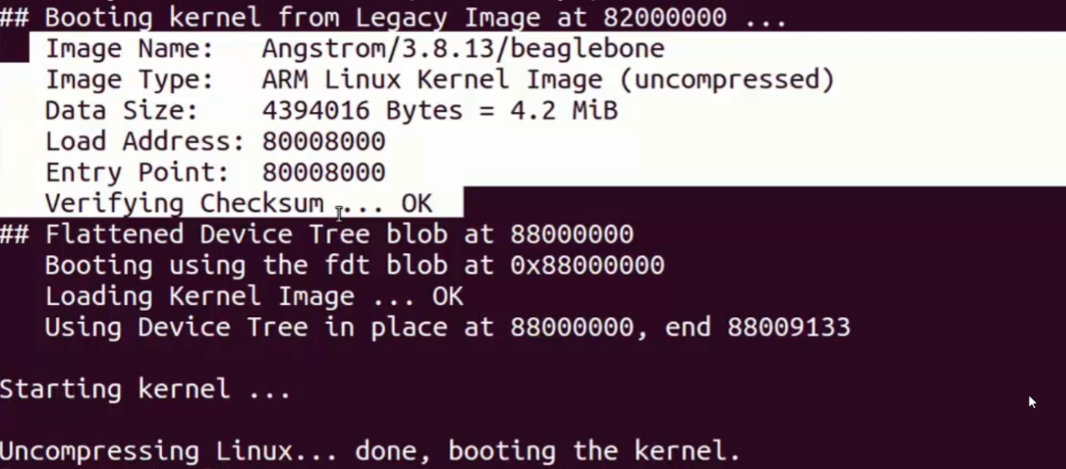

- While booting the kernel, it will print the all Zimage header information
- Starting Kernel is the last print executed by U-boot after this the control take care by linux kernel bootstrap loader

Decoding the U-boot Header of UImage Manually using U-boot commands

Reading U-boot header information of the UImage Manually
- Do power cycle to boot from SD card
- Watch this message on minicom: Hit any key to stop autoboot: 3 press any key now it will enter to U-boot

U-Boot: load mmc 0:2 0X82000000 /boot/uImage
MMC0 SD card
MMC1 eMMC
So mmc 0
0:2 second partition
DDR RAM copy to address
/boot/uImage UImage directory to copy the UImage to DDR RAM


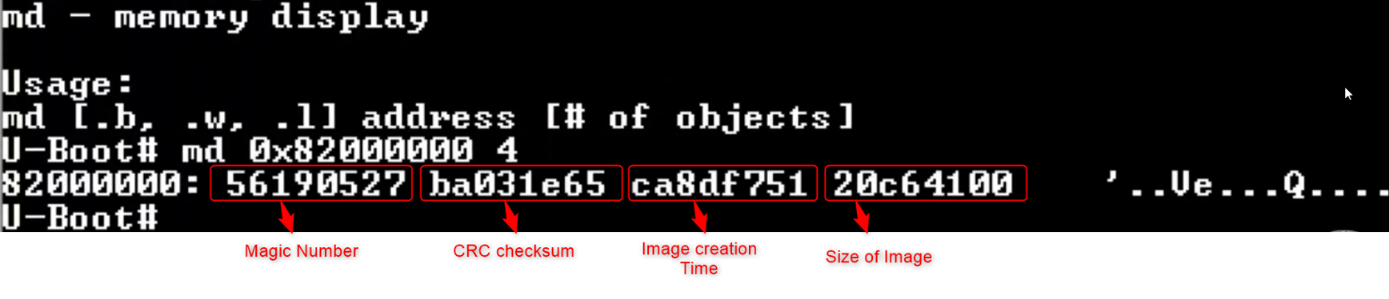

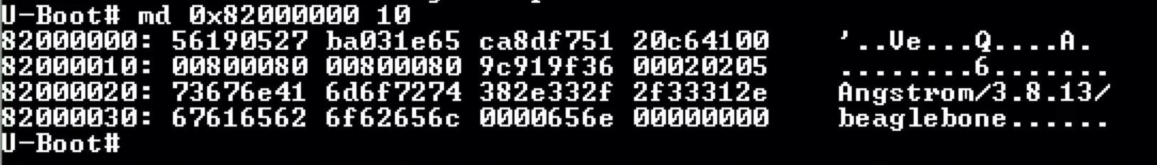

U-Boot# imi 0X82000000 This command directly decodes header only and prints in structured way
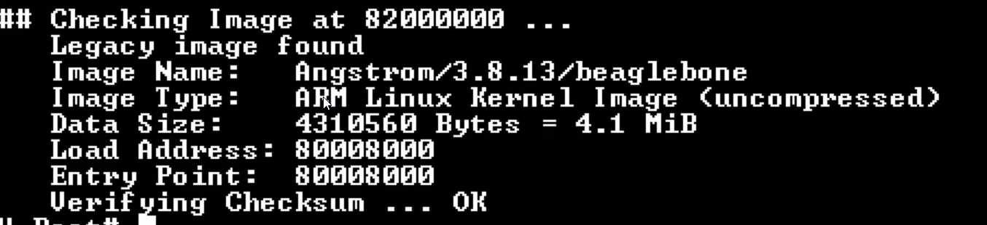

U-Boot to Linux boot flow
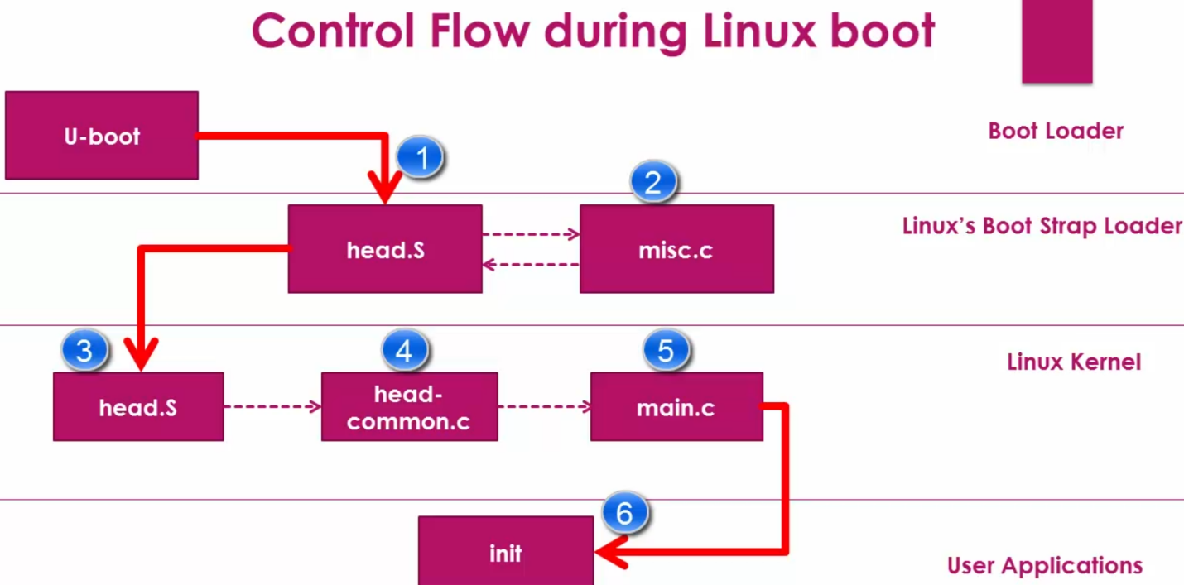

Kernel Entry U-boot
- Arch/arm/lib/bootm.c file picks linux kernel image from memory and handover control to linux kernel
- Boot_jump_linux() used to pic kernel image from memory and handovers the control to linux boot strap loader
- Kernel_entry it is a function pointer is defined which carry address of entry point of kernel image
- Kernel_entry(0, machid, r2) r2 carries the address of dtb, machid it is a machine ID
- Kernel_entry is dereferenced with parameter of machid it is machine ID is different for boards
- After deferencing the control reaches to head.s file

Head.s
- Located at arch/arm/boot/compressed/head.s
- Head.s file do some assembly operations then it will call misc.c file
- Misc.c file will decompress the kernel Image
- After decompressing the kernel image head.s hanover control to another head.s file
- The second head.s present in arch/arm/kernel
- Head.s is a architecture specific code like arm related things will be initialized here such as
  - CPU specific initialization
  - Checks valid processor architecture
  - Page table inits
  - Initialize and prepare MMU for the identified processor architecture\
  - Enable MMU to support virtual memory
  - Calls start_kernel function of the main.c (“Arch independent code”)
- Head.s also identifies the processor type and it will do the processor specific initialization
- The processor specific initialization files can be found on arch/arm/mm/
- Finally head.s file will call the head-common.c file

Head-common.c
- Simply calls the main.c

Main.c
- It is a architecture independent kernel main.c file meaning it’s a common main.c for all boards
- Start_kernel() is the entry point
- It initializes all kernel related things starts from kernel thread to mounding root file system all the way to executing very first user application function
- After initializing all kernel related things, it will call rest_init()
- Rest_init() initialize two kernel threads named kernel_init and kthreadd.
- And starts the scheduler and kernel goes to idle while(1) loop
- Kernel_init this thread will frees the memory (DD RAM) used during initialization because those functions no longer needed
- It will try to call the application init by following order if 1st fails calls the 2nd and so on if everything fails it throws error init failed
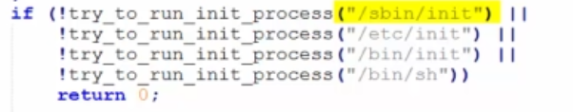

UEnv.txt and Initramfs
- UEnv.txt file is a collection of various env variables which are initialized to number of Uboot commands and automating the command execution
- Use help command in U-boot terminal to check the available commands
- U-boot depends on various environmental variables
- Printenv command shows all the available commands
- If I want to see the environmental variables value just use printenv socsoc=am33xx
- To create new env variable setenv serverip 192.168.27.1 then print and check availability printenv serverip serverip=192.168.27.1
- Also, we can create a variable to run command
- run bootcmd will execute the cascading commands

mmc list shows all available mmc hardware in the board
OMAP SD/MMC: 0 (SD)
OMAP SD/MMC: 1
Creating an env variable to hold the above command
Setenv my_mmc_list ‘mmc list’
printenv my_mmc_list
my_mmc_list=mmc list
run my_mmc_list
OMAP SD/MMC: 0 (SD)
OMAP SD/MMC: 1

Creating uEnv.txt
- boot Try to boot the linux kernel the log shows that It actually try to read the uEnv.txt file
- boot try to run bootcmd env variable,bootcmd runs the multiple commands
- load load a binary file from a filesystem

Eg: Load Uimage which present inside eMMC memory to DDR memory

Boot from DDR
mmc list
OMAP SD/MMC: 0 (SD)
OMAP SD/MMC: 1
load mmc 0:1 0X8200000 uImage 0:1 0 mmc, 1 partition
11334208 bytes read in 732 ms (14.8 Mib/S) copies Uimage from mmc 0 partition 1 to 0x82000000 address which is DDR
bootm 0X82000000 boots kernel image from 0X82000000 address which is DDR
Boot failed because dtb file is not present and we did’nt loaded so next we will add dtb

Load dtb to memory
load mmc 0:1 0X88000000 am335x-boneblack.dtb loads dtb file to DDR ram
105136 bytes read in 14 ms (7.2 Mib/S)
bootm 0x82000000 – 0x88000000 Now it is booted but we could’nt see any logs lets enable it

Enabling debug messages
- The kernel has no idea which debug uart console is configured to send boot logs, for BBB UART0 is configured as serial debug terminal, which is enumerated as /dev/ttyO0 by the serial driver
printenv bootargs not created let’s create
setenv bootargs console=ttyO0, 115200
printenv bootargs
bootargs=console=ttyO0, 115200

Now execute the commands in the below order
  - load mmc 0:1 0X8200000 uImage
  - load mmc 0:1 0X88000000 am335x-boneblack.dtb
  - setenv bootargs console=ttyO0, 115200
  - bootm 0x82000000 – 0x88000000
Now we could see the boot logs, but still we got kernel panic error because we didn’t still load the rootfs
- Update bootargs rootfs present 2nd partition
  - setenv bootargs console=ttyO0, 115200 root=/dev/mmcblk0p2 rw
Now execute the commands in the below order
  - load mmc 0:1 0X8200000 uImage
  - load mmc 0:1 0X88000000 am335x-boneblack.dtb
  - setenv bootargs console=ttyO0, 115200 root=/dev/mmcblk0p2 rw
  - bootm 0x82000000 – 0x88000000

Now it is successfully booted

Creating uEnv.txt file
- Create a file named UEnv.txt and type the following (make sure new line is there end of file)
- mypcip=setenv serverip 192.168.1.2

- Transfer the file from PC to BBB board using loady command serial com supports file transfer using any modem protocol, after transfer complete it will show number of bytes transferred not that I will need for upcoming command
- Once transfer execute the below command to fetch the environmental variable and load it on uboot environment
- printenv mypcip
Error mypcip not defined
- env import -t 0x82000000 36 36 bytes
- printenv mypcip
mypcip=setenv=serverip 192.168.1.2
- run mypcip
- printenv serverip
- serverip = 192.168.1.2
Now add all the command in the eEnv.txt file the final file will look like below
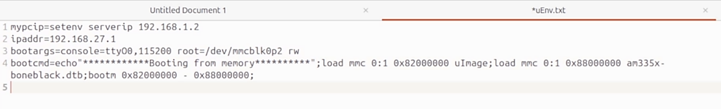

After importing use import command to add uboot env finally run boot command

Initramfs
- initramfs (Initial RAM File System) is a compressed temporary root filesystem loaded into RAM during early Linux boot to help the kernel start properly.

Is initramfs compulsory?
No
It is optional, mainly used in embedded Linux systems.

Why initramfs is used?
Instead of building all drivers into the kernel:
- store drivers in initramfs
- load them during boot
- initialize peripherals
- then switch to main filesystem (SD card / eMMC / network)
This keeps the kernel smaller and flexible.

What does initramfs contain?
Typically:
- device drivers
- firmware files
- boot scripts
- utilities
- logos (optional)
Purpose: provide minimum environment for boot

How initramfs is loaded?
Two methods:
- Built into kernel during compilation
- Loaded separately via bootloader + kernel arguments

Steps to generate initramfs
Step 1: Create cpio archive
find . | cpio -H newc -o > ../initramfs.cpio
Step 2: Compress archive
gzip < ../initramfs.cpio > ../initramfs.gz
Step 3: Install tools
apt-get install u-boot-tools
Step 4: Add U-Boot header
mkimage -A arm -O Linux -T ramdisk -C none -a 0x80800000 -n "Root Filesystem" -d ../initramfs.gz ../initramfs
Final output:
initramfs
Used as RAM-based root filesystem during boot

Booting BBB over Serial Port
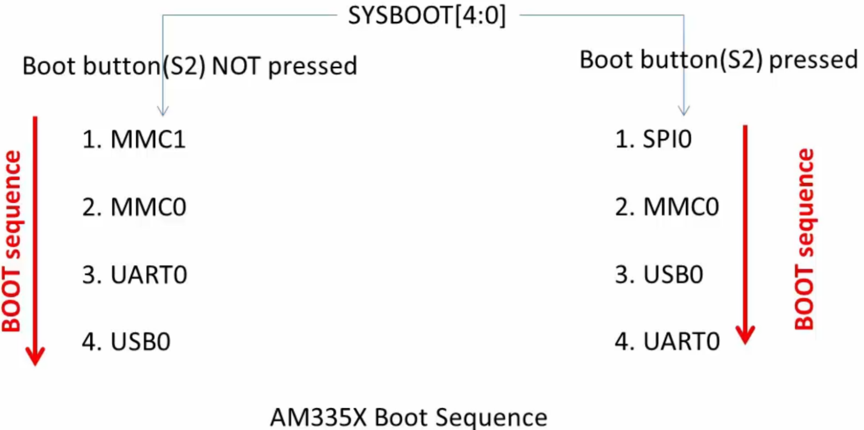

- Disconnect SD card so it will first try to boot SPI since SPI is not connected now It will try MMC0 since we removed SD card it will try USB(P4 mini USB should be free no USB is allowed to connect), it will also fail finally it will try boot via UART
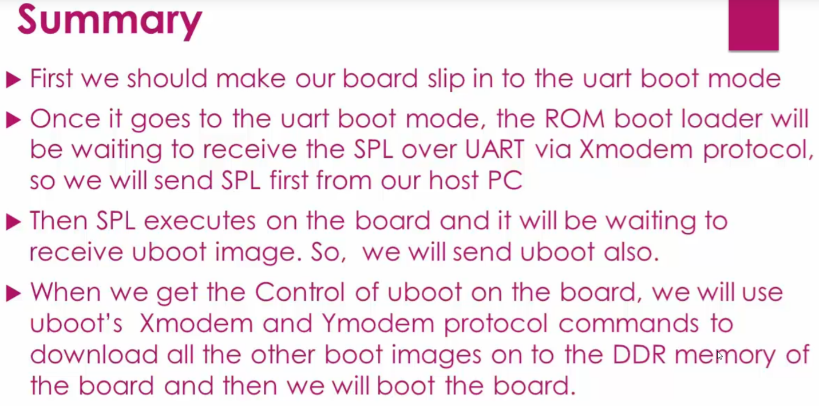
e

- Connect UART debugger pins only
- Open minicom
- Press and hold the boot pin and press power button to start the board, now it will enter the UART boot mode and it will start printing the CCC
- Download and keep the pre built binaries in your PC
- In the minicom we are going to use protocol called xmodem to transfer files from our PC to BBB DDR ram address to do that use this short cut ctrl + a release ctrl + a and then press S it will pop up window as like below
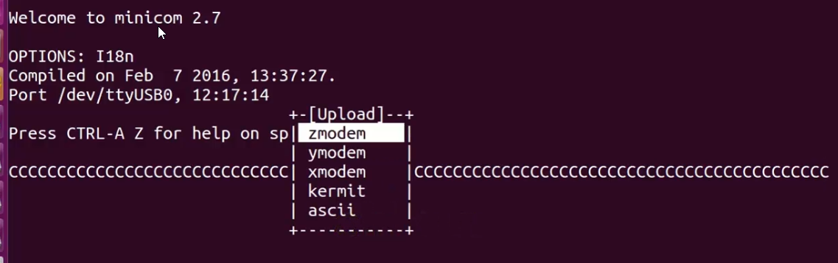

- Select xmodem using up and down arrow to select press enter
- Navigate to your PC where the pre-built binaries are stored to select folders press space bar twice
- Select sp.bin To select file press space bar once the press enter it will start writing the internal RAM Of SoC(not DDR)
- Now the SPL is looking for U boot
- Use the same steps to select u-boot.img and transfer to DDR memory
- Once transfer completed Press space bar to stop it on U-boot
- Now we are in U-boot prompt
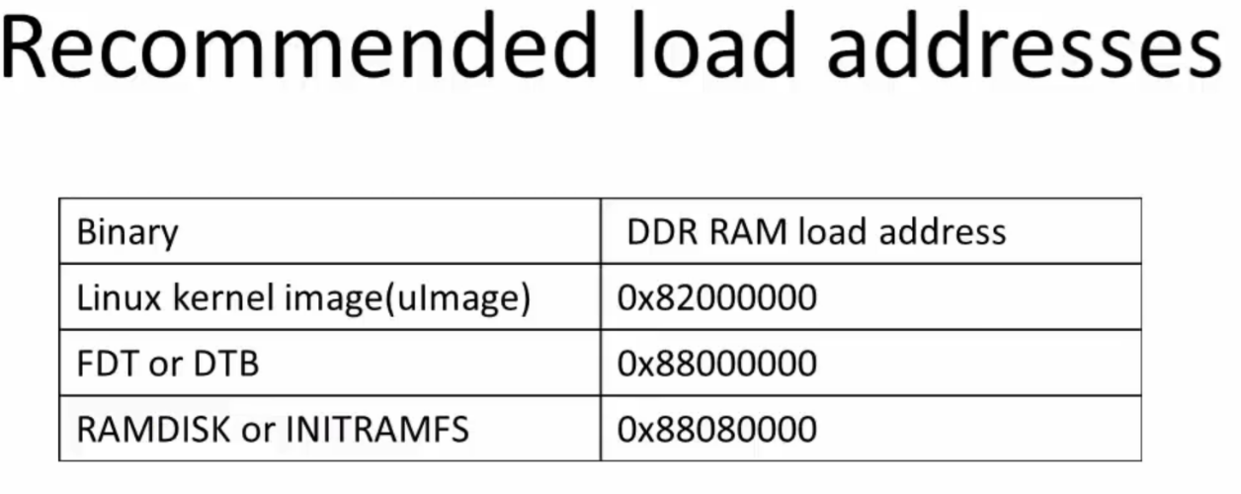

- Use loadx 0x82000000 this command selects the DDR memory location, if you did write then it will be written to this address, now we are going to write the kernel image from our PC to this address via xmodem protocol
- Do the same steps to select and download the UImage via xmodem protocol
- Now load the DTB file to DDR ram using same xmodem protocol to do that run this command first loadx 0X88000000
- Same for intiramfs loadx 0x88080000
- Now set the bootargs before booting using the below command
- setenv bootargs console=ttyO0,115200 root=/dev/ram0 rw initrd=0x88080000
- Now boot bootm 0X82000000 0X88080000 0x88000000

TFTP booting protocol

Prerequisites
- Power the board using either connecting to PC via USB cable or using DC adapter.
- Connect Ethernet port of the BBB hardware to PC's Ethernet port using Ethernet cable.
- We will also use SD card for this experiment. Meaning TV
- TFTP stands for trivial transfer protocol Which can be used to transfer between TFTP server and TFTP client
Connection between host PC and BBB board.
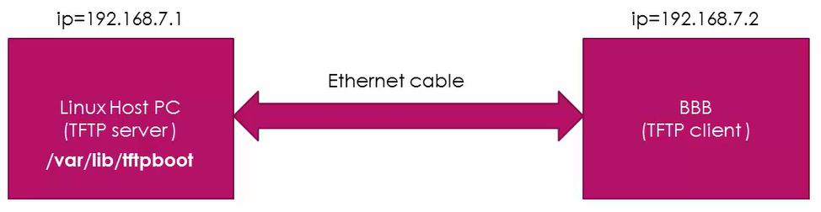

- The DTB U-image initramfs will be present on host PC in the following directory which is /var/lib/tftpboot.
- The big picture is we will keep all the SPL U-boot.img and UEnv.txt on eMMC card to boot till U-boot then we will transfer DTB, U-image initramfs from host PC Using TFTP protocol using uboot commands
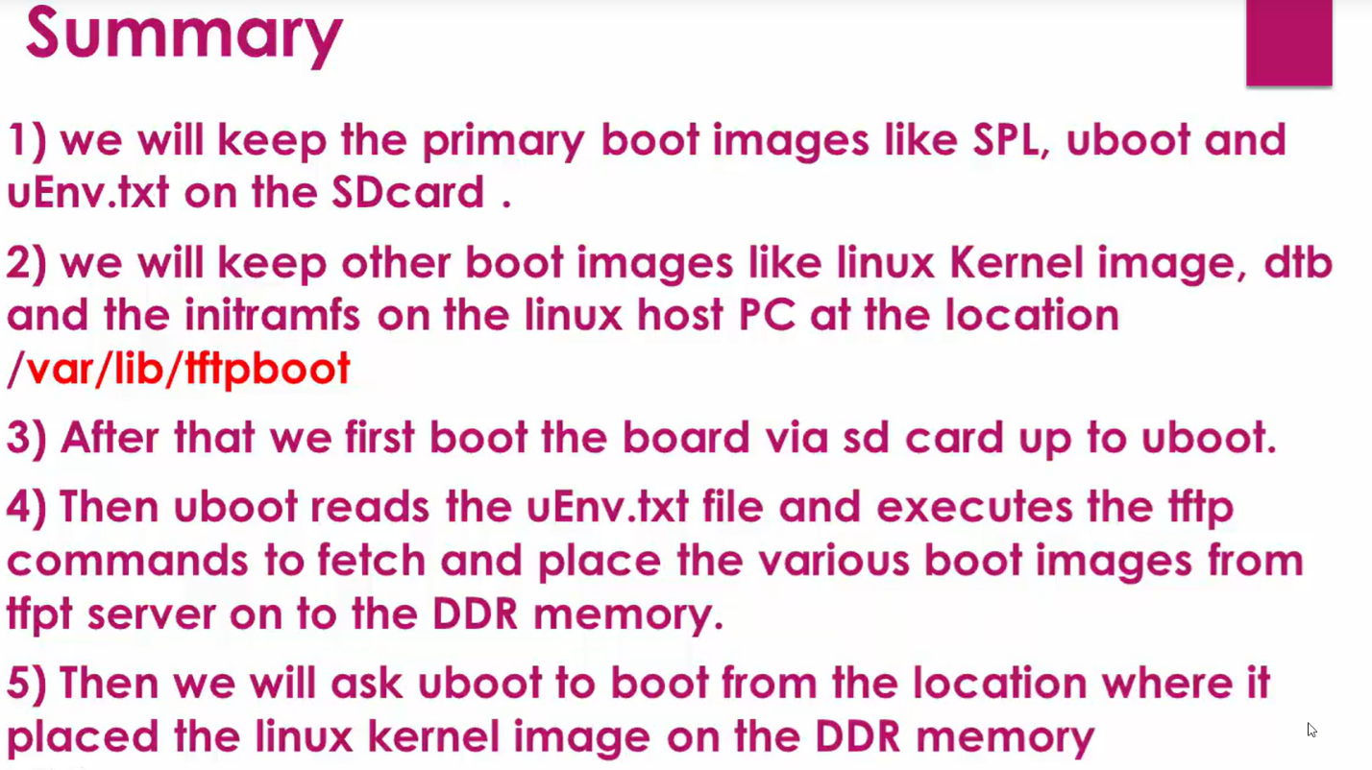

use the following steps to prepare a hostel TFTP server, End of this, steps, We We will project the particular folder.
Preparing TFTP host
Setting up a TFTP server on Ubuntu host
Step 1: First on your Ubuntu host run the below command using your terminal program.
$ sudo apt-get update
$ sudo apt-get isntall
$ sudo apt upgrade
Step 2: install TFTP server
$ sudo apt-get install tftpd-hpa
This command installs the tftpd deamon. tftpd is a server for the Trivial File Transfer Protocol.

Step 3 : Create/Open the file “tftpd-hpa” in the below directory
$ sudo vim /etc/default/tftpd-hpa and put the below entry in to this file and save it
Step 4: Add the Following Entries: Inside the file, add the following entries:
TFTP_USERNAME="tftp"
TFTP_DIRECTORY="/var/lib/tftpboot"
TFTP_ADDRESS=":69"
TFTP_OPTIONS="--create --secure"
Step 5:
Create a folder /var/lib/tftpboot and execute below commands
$ sudo mkdir -p /var/lib/tftpboot
$ sudo chown tftp:tftp /var/lib/tftpboot
$ sudo chmod -R 777 /var/lib/tftpboot
Step 6:Now we can start the TFTP daemon.
$ sudo systemctl start tftpd-hpa
Resources for this lecture

- Open minicom in BBB
- Set server IP address using this command setenv serverip 192.168.27.1
- Set board client IP address setenv ipaddr 192.168.27.2
- Ping 192.168.27.1 ping server from client(BBB)
- Now load linux kernel Image, DTB, initramfs
- To load linux kerne image use this command tftpboot 0x82000000 UImage
- To load DTB use this command tftpboot 0x88000000 am335x-boneblack.dtb
- To load initramfs use this command tftpboot 0x88080000 initramfs
- Now set bootargs setenv bootargs console=ttyO0,115200 root=/dev/ram0 rw initrd=0x88080000
- Now boot bootm 0X82000000 0X88080000 0x88000000

Advantage:
- Let say kernel image is changed, it is easier way to flash kernel image
- If you want to transfer any file just keep the exposed / projected directory then it is easy to get it in BBB using TFTP protocol
- Use this command in BBB to pull the file from host pc:
- Set ip address first ifconfig eth0 192.168.72.2 the run this command to copy helloworld file from TFTP server to host i.e our PC to BBB tftp -r helloworld -g 192.168.27.1 the us ls to see the file

U-Boot
- Clone the U-boot source from this link : https://openbeagle.org/beagleboard/u-boot/-/tree/v2022.04-bbb.io-am335x-am57xx
- Download and uncompress
- Arch folder contains architecture related folders
- Board folder contains lot of board files
- Boards/ti/am335x BBB board file
- Arch/arm/cpu arm related architecture folders
- Arch/arm/cpu/arm7/start.s the file which jumps from ROM to SPL
- Configs configuration files for different boards
- File name ends with defconfig default configuration

Compiling U-boot and MLO

Cross tool Chain Installation
- https://releases.linaro.org/components/toolchain/binaries/latest-7/arm-linux-gnueabi/gcc-linaro-7.5.0-2019.12-x86_64_arm-linux-gnueabi.tar.xz
- Donwload and extract cross tool chain using above link
- Export the path of tool chain got to bin folder copy the directory link and add this line in vi /home/kiran/.bashrc scroll to end and add it export PATH=$PATH:/home/kiran../directory which the bin folder of tool chain save and quit
- Run source command to update the changes made in .bashrc source /home/kiran/.bashrc
- The U-boot image compilation can be done using two menthod
  - 1. Using the script
  - 2. Using manually commands
The script provided by u-boot firmware

Method 1
- The name of script is build-am335x.sh
- Before execting the script provide execution permission using this commandsudo chmod +x build-am335x.sh
- Now run sudo ./build-am335x.sh

Method 2
STEP 1: distclean : deletes all the previously compiled/generated object files.
make CROSS_COMPILE=arm-linux-gnueabihf- distclean
STEP 2 : apply board default configuration for uboot
make CROSS_COMPILE=arm-linux-gnueabihf- am335x_boneblack_defconfig
configuration written to .config
STEP 3 : run menuconfig, if you want to do any settings other than default configuration .
make CROSS_COMPILE=arm-linux-gnueabihf- menuconfig
STEP 4 : compile
make ARCH=arm CROSS_COMPILE=arm-linux-gnueabihf- -j4 // -j4(4 core machine) will instruct the make tool to spawn 4 threads
make ARCH=arm CROSS_COMPILE=arm-linux-gnueabihf- -j8 // -j8(8 core machine) will instruct the make tool to spawn 8 threads

After the compilation it will generate U-boot.img. MLO and SPL.bin

Linux kernel Image build
- Download linux kernel image from this repo : https://github.com/beagleboard/linux/tree/v5.10.168-ti-rt-r76
STEP 1:
make ARCH=arm CROSS_COMPILE=arm-linux-gnueabihf- distclean

STEP 2:
make ARCH=arm CROSS_COMPILE=arm-linux-gnueabihf- bb.org_defconfig (4.4)
for 4.11 use omap2plus_defconfig
STEP 3:
make ARCH=arm CROSS_COMPILE=arm-linux-gnueabihf- menuconfig

Note If it is selected as ‘M’ those are dynamically loadable module, those are not yet compiled
If * then it is selected and compiled by kernel
If <> those are deselected modules which are not part of kernel image, remove unwanted entries (drivers) to reduce final kernel image size

STEP 4:
make ARCH=arm CROSS_COMPILE=arm-linux-gnueabihf- uImage dtbs LOADADDR=0x80008000 -j4
STEP 5:
Compiles and generate loadable kernel modules with extension of .ko
make ARCH=arm CROSS_COMPILE=arm-linux-gnueabihf- -j4 modules

STEP 6:
All the modules are installed on our PC we need to install it on root file system
make ARCH=arm CROSS_COMPILE=arm-linux-gnueabihf- INSTALL_MOD_PATH=<path of the RFS> modules_install

BusyBox
- it's a software tool that enables you to create a customized root file system for your embedded linux products

Advantages of BusyBox
- It enables you to create customized file system that meets your resource requirements
- if your product is resource limited in terms of memory then you can customize the files system such a way that it can fit into your product with Limited memory space.
- We can use this tool to remove all unwanted features which your product doesn't need. Like you can remove unwanted Linux commands and features, directories etc. Using this customization tool.
- It has the potential to significantly reduce the memory consumed by various linux commands by merging all the Linux commands in one single binary.
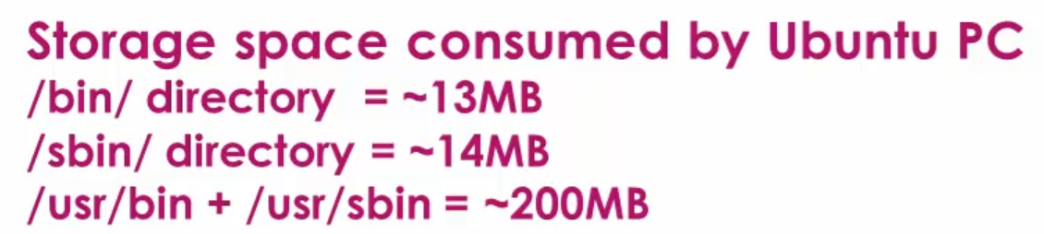

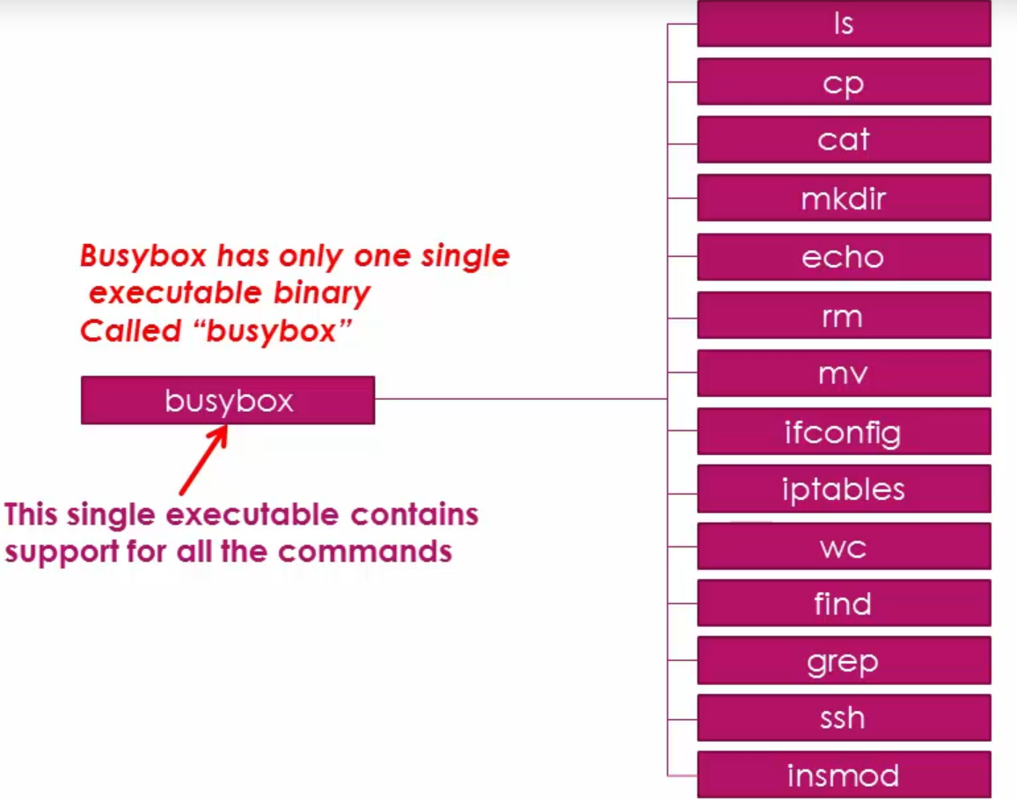

Busybox compilation
STEP 1: download busybox link : https://busybox.net/downloads/
STEP 2 : Apply default configuration
make ARCH=arm CROSS_COMPILE=arm-linux-gnueabihf- defconfig
STEP 3 : change default settings if you want
make ARCH=arm CROSS_COMPILE=arm-linux-gnueabihf- menuconfig
select static build libiraries means instead of dynamic build we are incorporating all libiraries as static to do this select this option BusyBox settings select Build Busybox as a static library (no shared libs) save exit

STEP 4 : generate the busy box binary and minimal file system
make ARCH=arm CROSS_COMPILE=arm-linux-gnueabihf- CONFIG_PREFIX=<install_path> install
<install_path> give your workspace in PC
After build go to the directory (<install_path>) ls we could see the below folders and files
bin linuxrc sbin usr
cd bin/ ls ls -1 | wc -l 89 commands
execute the same command in our PC ls -1 /bin/ | wc -l 162 means the 162 commands are reduced to 89 commands
similarly test for sbin, busybox sbin 70 , PC sbin 201
All the commands are soft link to Busybox means we have only one command named busybox under bin and sbin
- To check the size of busybox run du -sh 1.4M
- To install kernel into root file system go to the downloaded folder and execute this command make ARCH=arm CROSS_COMPILE=arm-linux-gnueabihf- CONFIG_PREFIX=/home/kiran/BBB_Workspace/RFS _static modules_install
- New folder will be created named lib, also manually create one more folder named dev and keep it empty
- Libs/firmware and libs/modules/4.4.62/kernel/drivers/* this directory we will find all the driver files
modprobe command is used to load the kernel modules this is intelligent command which checks the dependencies first if not satisfied only it will load

Testing Boot image and busybox on BBB

- Create a directory named compiled_bins
- Copy u-boot.img, MLO, u-boot-spl.bin, uImage, am335x-boneblack.dtb
- Keep MLO, u-boot.img, uEnv.txt in SD card
- We will load the “uImage” from the host PC using “TFTP” protocol
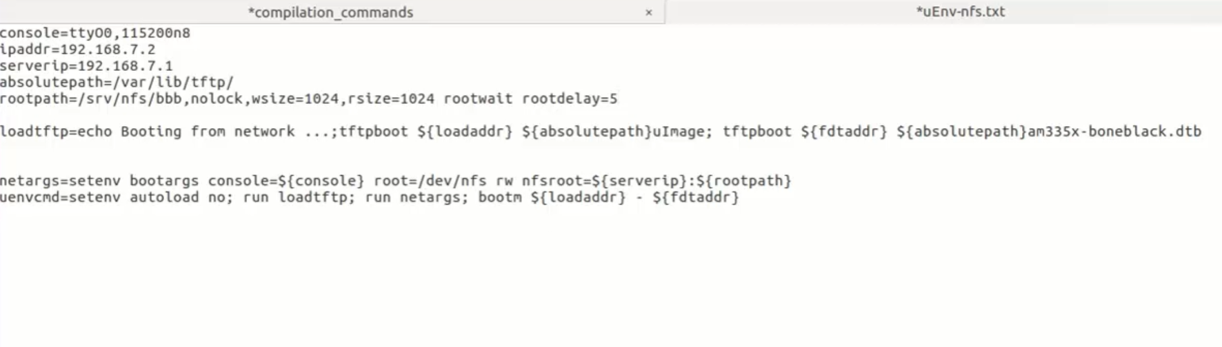
- We will mount the “RFS” using “NFS” protocol

Tftpboot, nfsroot are commands
- • TFTP loads the kernel (uImage) and device tree (.dtb) into RAM
- • NFS provides the root filesystem (rootfs) after the kernel starts running
Power ON
↓
U-Boot starts
↓
TFTP → downloads uImage (kernel)
TFTP → downloads am335x-boneblack.dtb
↓
Kernel begins execution
↓
Kernel mounts rootfs via NFS
↓
/sbin/init runs
↓
Linux user space starts
Enabling NFS server to provide access to client
- Open the file etc/exports add this line

configure ipconfig in host pc and add this content to do that open
/etc/network/interfaces
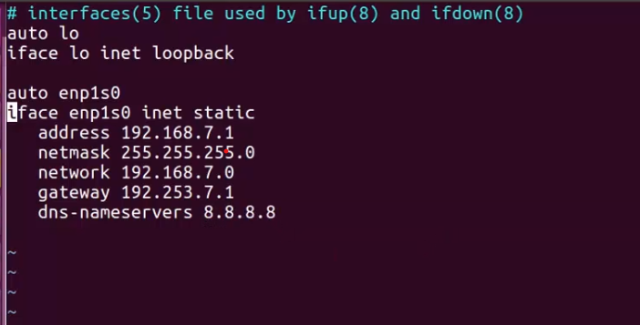

And run the following three commands
sudo exportfs -a
sudo exportfs -rv
sudo service nfs-kernel-server restart
sudo service nfs-kernel-server status

Remove the SD card boot via SD card now it boots and uses TFT Protocol to load UImage and dtb, an
D NFS protocol will mounts the busybox rootfs and finally it is booted and shows #

Init Program of BusyBox

- Linux init usually do it in two way as mentioned below
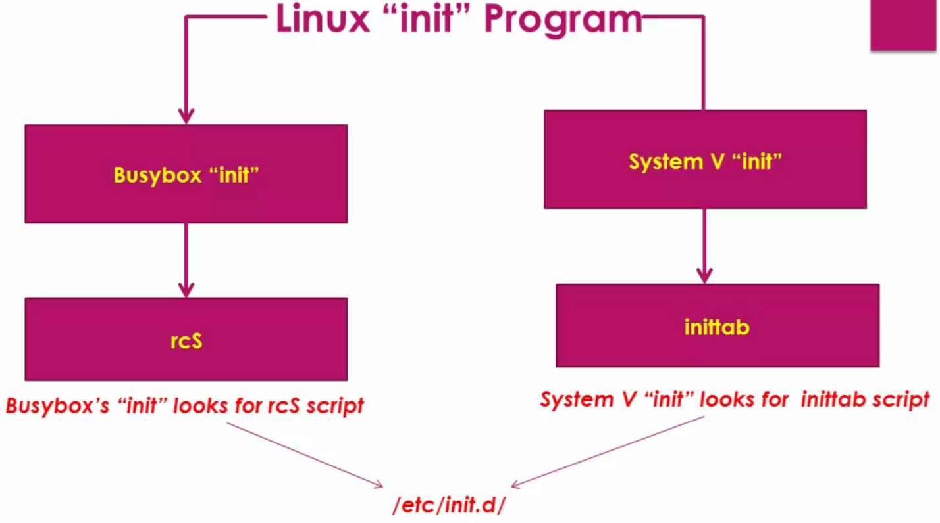

End of the boot we could see an error as like below which confirms it looks for rcS script which should be present in this folder /etc/Init.d/
rcS is just a init script here we can write what ever we want as like below like start ssh, start NFS, and so on

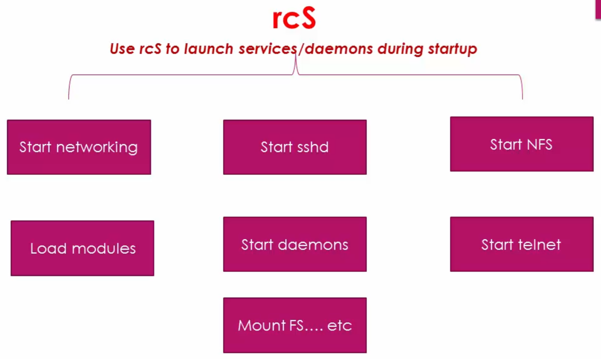

We are going to write the following scripts
- rcK kill (shutdown) services
- rcS start services
- S01Logging starting the logging service
- S04networkstarting the network
- S05sshd starting the ssh demone service (connecting files remotely)
- The file name of the sub scripts should start with S and the number after this S defines the order of execution in this case S01 executes fist S05 execute last

Crate a folder named init.d under srv/nfs/bbb/ etc/init.d
Copy paste all files inside this directory

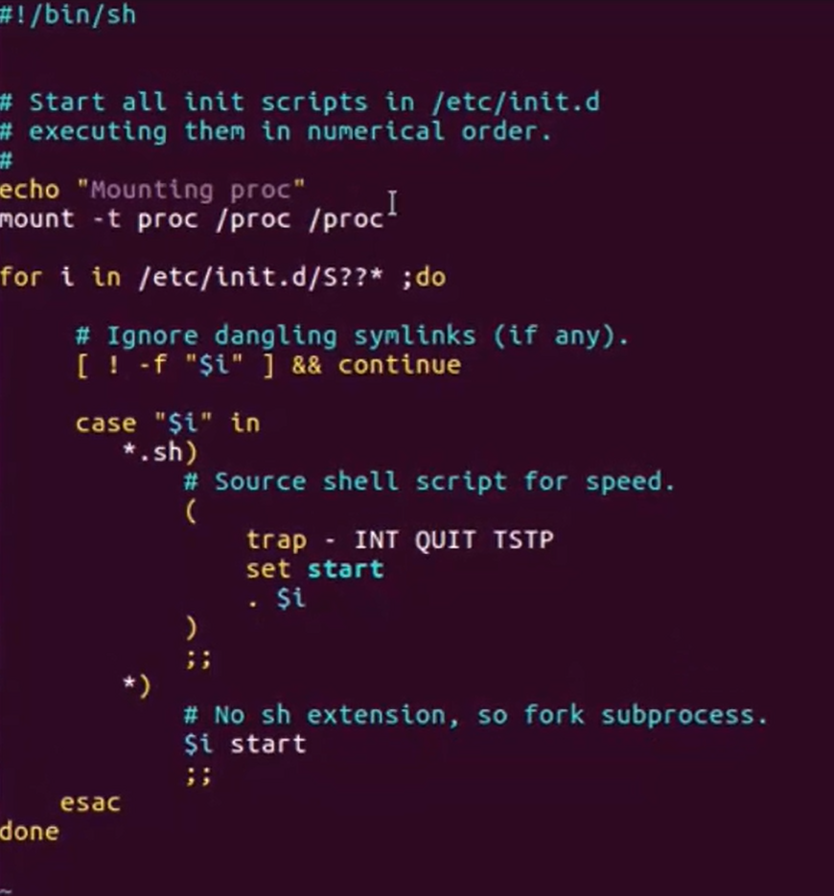
rcS file:

- mounting proc system is required for some commands
- There is a for loop which starts all the script which starts with letter S

S01Logging
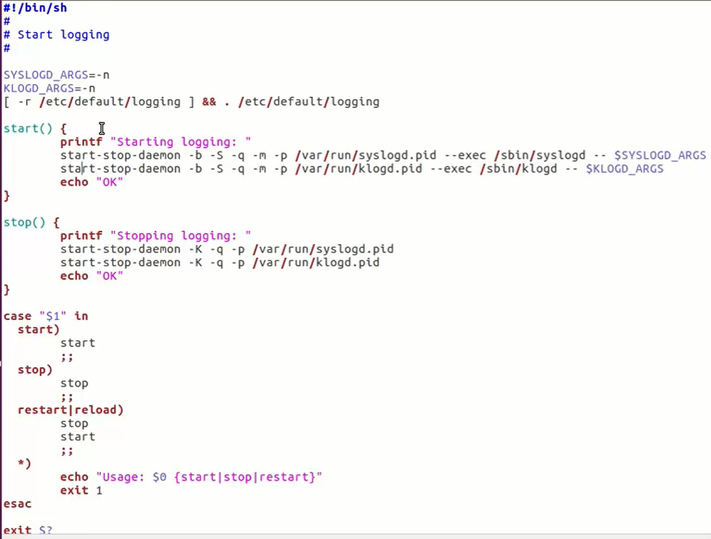

It has two function start and stop, start is executed by rcS and rcK script
In start() it executes the syslog and klog which is system log and kernel log
Similarly for stop() it kills the syslog and kernel log

S04network
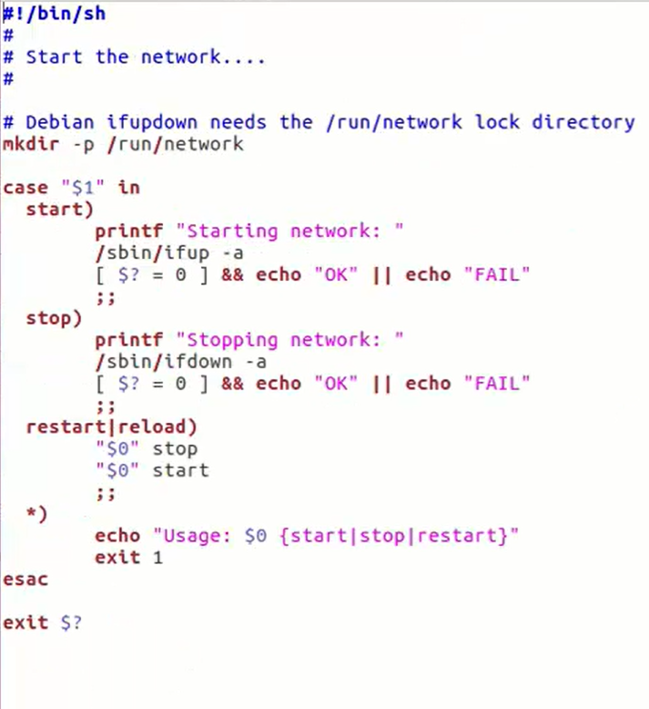

On start()Ifup trying to up the network
On stop()Ifdown trying to down the network

S50sshd
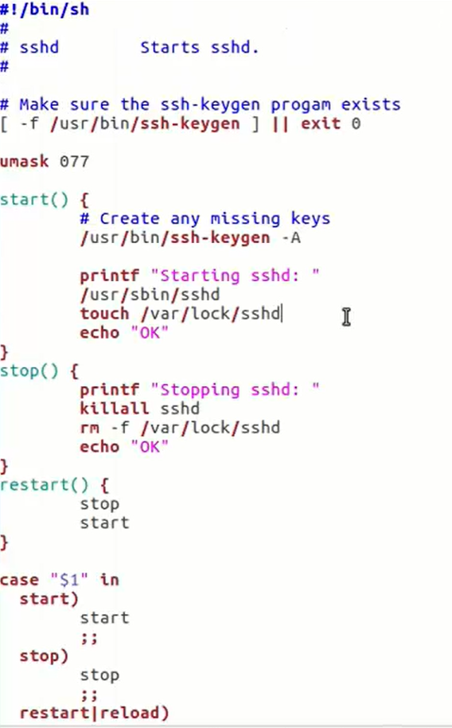

Also need to create proc folder in srv/nfs/bbb/mkdir proc
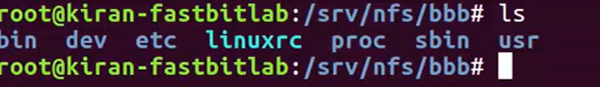
The folder will look like this

Reboot the board
Got error /et/network
Execute the command to check manually on BBB ifup -a we got error means no file called /etc/network/interfaces

We have connected our board and PC via ethernet and USB, if we execute the command ifconfig in PC we could see only eth0 is present not usb
To enumerate it the driver is missing it is not loaded

TO install the compiled binaries we have to execute this command
make ARCH=arm CROSS_COMPILE=arm-linux-gnueabihf- INSTALL_MOD_PATH=<path of the RFS> modules_install

Now the lib folder is created, lib/modules/4.4.62/kernel/drivers/
Reboot
In BBB terminal modprobe g_ether
lsmod
ifconfig usb0 192.168.6.2 up
ifconfig now the usb0 is created
Now the PC is detected the USB over ethernet
In host PC also if we use ifconfig the it will show enc0s20u3u2 which is nothing but the USB over ethernet connection
We can configure IP address for this in host pc
ifconfig enc0s20u3u2 192.168.6.1 up
ping 192.168.6.2 it is pinging the BBB via USB0 ethernet connection
Also ping from BBB possible ping 192.168.6.1
The modules are dynamically loaded how to make it automatically load let see

Auto loading of drivers during system startup

Logon to BBB
Create the file touch /etc/network/interfaces
Copy past the contents below
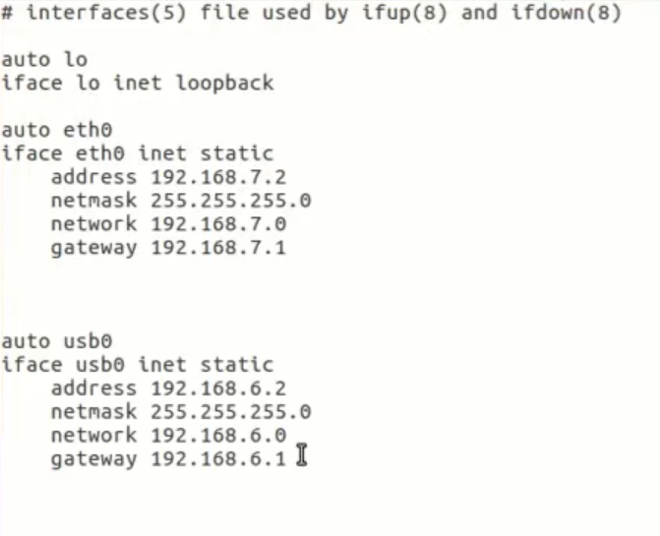

Before bring up the usb we need to load the drivers so create a new script named
S02module remember 02 is used because before ip up we have to load the driver so ip up script number is 40 so we used 02
S02moudle
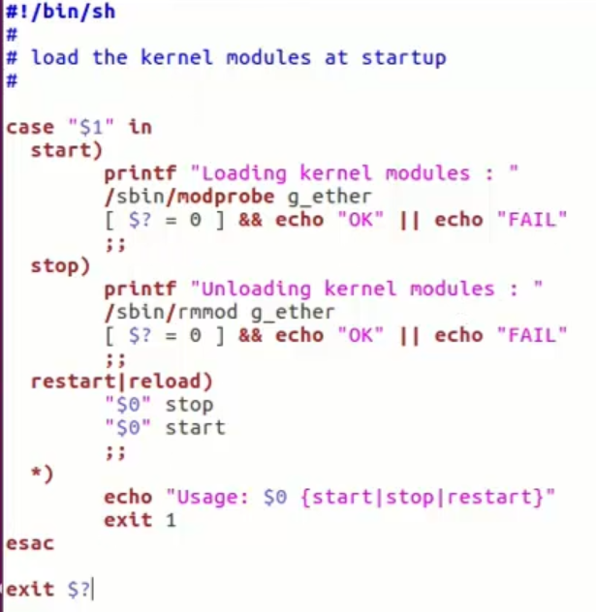

Give executable permission chmod 777 *
Transfer the newly created file to srv/nfs/bbb/etc/init.d
Reboot the board
Now the USB0 is enumerated
But the interface is not up
Cat /etc/network/interfaces actually we have this settings
Exectute the command manually ifup -a got error if-pre-up.d : No such a file or directoy
Ifstate.new : No such a file or directoy
Create these two files on this location keep it empty
Reboot the board
Now usb over ethernet enumerated

Build root

- Build root is a simple, efficient and easy to use tool to generate embedded Linux system through cross compilation
- It can do all the compilation we saw earlier like kernel, MLO, bootloader, Uimage everything there is a menu config using that we can select and deselect requireedm packages and we can build it
- It supports lot of middleware and packages
- Build root can be downloaded using this link : https://buildroot.org/download.html
- Buildroot-2017.05/configs contains lot of configs for different boards available in the market
- Buildroot-2017.05/boards contains board files these are already test by build root
- Buildroot-2017.05/boards/beaglebone/readme,txt explains how to build for beaglebone
- Build root capable to build these binaries
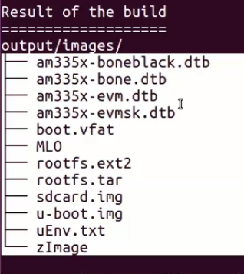

Configuring and building buildroot
- Buildroot-2017.05 make beaglebone_defconfig
- make menuconfig this will open the GUI configuration window to select and deselect the features or binaries we want
- Tool chain Toolchain Type Buildroot toolchain and External Toolchain
  - If Buildroot toolchain selected then build root automatically download the required tool chain and install it
  - External Toolchain is selected then we have to provide path of locally installed toolchain (in our case select external toolchain option)
- Toolchain if Linaro already installed then it will by default select it automatically
- Toolchain origin Pre-installed toolchain
- Toolchain path provide tool chain installation directory till bin
- System configuration system hostname give my name
- System banner welcome to buildroot-BBB
- Init system Busybox
- Root password root
- Run a getty (login prompt) after boot ttYO0 baudrate 115200
- Linux kernel disable we already built it
- Target Packages Networking applications openssh(select it)
- Bootloaders disable U-boot
- Exit Save (yes)make -j4
- We will get MLO error like post-image.sh because we didn’t generated MLO just leave the error rest of the things are built that can be found in output/images
- Delete the existing rootfs files present in srv/nfs/bbb
- Extract tar -xf rootfs.tar -C /srv/nfs/bbb
- Reboot the board
- Enter root password to login board
- Ping 192.168.7.1 to ping the PC from BBB
- Try SSH from host PC ssh -l root 192.168.7.2
- Enter password Permission denied error
- cd srv/nfs/bbb/etc/ssh/
- vi sshd_config Uncomment PermitRootLogin yes save close
- reboot the board
- From the host pc ssh -l root 192.168.7.2
- Password now logged in
- From BBB host pc login steps install ssh server on HOST PC apt-get install openssh-server
- Go to BBB ssh -l kiran@192.168.7.1 yes logged in

Build root and U-boot configuration
- Buildroot-2017.05 make menuconfig
- Kernel Linux Kernel kernel version
- URL of custom git repository (NEW) paste the kernel repository link
- Defconfig name bb.org
- Kernel binary format uImage
- Load address (for 3.7+ multi-platform image)0X80008000
- Build a device tree blob device tree source use a device tree present in the kernel
- Device tree source file names am335x-boneblack
- Exit
- Bootloader U-Boot U-boot version 2017.03
- Board defconfg am335x_boneblack_defconfig
- U-boot need dtc
- Exit save (yes)
- Make -j4
- Got error no file found named bb.org_defconfig
- Buildroot-2017.05 make menuconfig
- Kernel Linux Kernel Defconfig name omap2plusokexitsave
  - Note for kernel 4.11 use omap2plus_defconfig
- Make -j4
- cd outputs/images
- rootfs already copied so transfer only uImage and am335x-boneblack.dtb to /var/lib/tftboot and
- Reboot
- Now you could see the kernel version is changed uname -r

